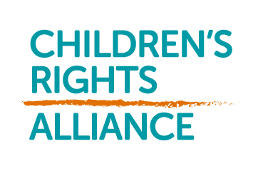
APPLICATION FOR MEMBERSHIP TO THE CHILDRENS RIGHTS ALLIANCE
Children’s Rights Alliance-Republic of Ireland Limited is a company limited by guarantee. This means that it does not have shares or shareholders, but instead it has members. It is governed by a board of voluntary directors who are elected by the membership and the work of the Children’s Rights Alliance is led by a Chief Executive and carried out by a staff team.
Full members are entitled to do the following:
- To attend and vote at general meetings; normally there will be one meeting per year, called the Annual General Meeting ( AGM) and you will be given at least 21 days’ notice of the place and time of the meeting. We may also need to call other general meetings in exceptional circumstances
- To receive the company’s annual accounts
- To elect directors by voting at the meeting and stand for election
- To vote on any fundamental changes to the nature of the Company, its name, its purpose, or what happens to its profile
While Associate and Individual members have access to all other Alliance membership benefits, they are not entitled to the above rights. You will not be entitled to receive any dividend or other income from the Company.
If the Company makes a profit, this will be retained to help pay for the Company’s activities in the following years. If the Company is wound up, you will not receive any money from the Company because its constitution requires that it should be given or transferred to some other Charitable Institution or Institutions having main objects similar to the main objects of the Company.
The constitution is made up of the memorandum and articles and the rules. The memorandum sets out what the Company can do and why it exists; and the articles deal with the holding of meetings, the admission of members, the election of members and other rules relating to the running of the Company. These are legal documents that are registered in the public records for the Company held at the Companies Registration Office.
You will not be liable for any debts of the Company by becoming a member. You will not be liable if someone brings a case against the Company. This is because, like most other companies, it is a limited Company, which means your liability as a member is limited. If the Company is wound up (which may happen for example, if it cannot pay its debts then you will have to pay no more than one euro to the Company. This is the amount you guarantee or promise to the Company by becoming a member, as set out in clause 9 of the memorandum. In addition, if you have paid a subscription to the Company, there may not be enough funds left to return any of that subscription to you, even if the winding up happens part way through a membership year.
If you would like to become a member, the procedure is as set out in the Articles.
To the Board of the Children’s Rights Alliance-Republic of Ireland Limited
I, (name of individual)
of (address)
wish to become a member of the Children’s Rights Alliance-Republic of Ireland Limited, subject to the provisions of the Memorandum of Articles of Associations of the Company (and to the rules). I agree to pay to the Company an amount of one euro if the company is wound up while I am a member or for up to 12 months after I have left the Company. I agree to pay any membership fee levied in accordance with the articles and rules.
Signed: Dated :
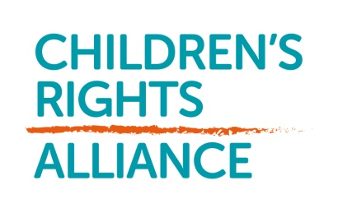

7 Red Cow Lane, Smithfield, Dublin 7
Tel: (01) 662 9400 Email: members@childrensrights.ie
Website: www.childrensrights.ie

MEMBERSHIP APPLICATION FORM

1. Name:
_____________________________________________________________

2. Address:
_____________________________________________________________
_____________________________________________________________
_____________________________________________________________

3. Contact details:

Tel: ____________ e-mail: ____________________

Protecting your privacy is important to us. The Children’s Rights Alliance complies with all
legislation and best practice in relation to storing personal information of our members and
supporters. We will never share your information with any other organisation.

4. Reason for joining/interest in the Alliance:
______________________________________________________________
______________________________________________________________
______________________________________________________________
DECLARATION

I hereby declare that I, …………………………………………….. (print name) is committed to supporting the principles and provisions of the UN Convention on the Rights of the Child and the purpose and work programme of the Children's Rights Alliance as set out in its Strategic Plan 2017-2021.

______________________ _______________________
Signature Date

*** Please return this application form by email to members@childrensrights.ie ***

